|  |  |
| --- | --- |
|  | **MINISTRY OF EDUCATION AND TRAINING** |

**FPT UNIVERSITY**

|  |  |
| --- | --- |
| Capstone Project Document | |
| **Face Detection For Delivery Payment** | |
| **Group 5 - IS** | |
| **Group members** | Nguyễn Văn Hiếu – SE61961 (Leader)  Đinh Phú Thắng – SE62528  Trần Trọng Nghĩa – SE62278  Nguyễn Hữu Lâm– SE61234 |

– **Ho Chi Minh City, 20 January 2019** –

# **E. Report No. 5 System Implementation & Test**

# **1. Introduction**

## **1.1 Overview**

This section provides in detail all necessary information about implementation information and testing procedure of FPS includes test plans, test cases, test result and risks estimations.

## **1.2 Test Approach**

- We use black box / white box….

# **2. Database Relationship Diagram**

## **2.1 Physical Diagram**

Figure Physical Diagram

## **2.2 Data Dictionary**

|  |  |  |
| --- | --- | --- |
| **Entity Data Dictionary: Describe content of all tables** | | |
| **No.** | **Table Name** | **Description** |
| 1 | Fr_account | Contain account information |
| 2 | Fr_city | Contain city information |
| 3 | Fr_district | Contain district data of city |
| 4 | Fr_order | Contain data of order’s list |
| 5 | Fr_order_detail | Contain data of order |
| 6 | Fr_payment_information | Contain data of payment |
| 7 | Fr_payment_type | Type of payment |
| 8 | Fr_price_level | Select price level for shipper |
| 9 | Fr_product | Contain data of every product of store |
| 10 | Fr_rating | Contain data rating of account for product and store |
| 11 | Fr_role | Contain data role of member |
| 12 | Fr_schedule | Contain open and close time of store |
| 13 | Fr_shipper | Contain data of shipper |
| 14 | Fr_source | Contain source of data |
| 15 | Fr_store | Contain data of store |
| 16 | Fr_weekday | Contian id for everyday (Monday, Tuesday, Sunday,…) |

Figure Data Dictionary

|  |  |  |  |  |
| --- | --- | --- | --- | --- |
| Entity | Attribute | Type | Visibility | Description |
| Fr_payment_type | id | integer | public | Unique identifier of a payment type. |
| type | String | public | Type of Payment |
| name | String | public | Name of payment’s type. |
| description | String | public | Description of payment’s type. |

Table Payment Type Attribute

|  |  |  |  |  |
| --- | --- | --- | --- | --- |
| Entity | Attribute | Type | Visibility | Description |
| Fr_payment_information | id | integer | public | Unique identifier of a payment information. |
| Fr_Account_id | integer | public | Linked to table of account |
| Fr_Payment_Type_id | integer | public | Linked to table of payment type |
| username | String | public | Username of account. |
| password | String | public | Password of account. |

Table Payment Information Attribute

|  |  |  |  |  |
| --- | --- | --- | --- | --- |
| Entity | Attribute | Type | Visibility | Description |
| Fr_account | id | integer | public | Unique identifier of account. |
| Phone_number | String | public | Phone number of account. |
| Fr_Role_id | integer | public | Linked to table of role. |
| password | String | public | Password of account. |
| name | String | public | Full name. |
| email | String | public | Email of account. |
| extra_point | integer | public | Extra point of account. |
| report_point | integer | public | Report point of account |
| user_image | Longblob | public | Image of account. |
| nation_id | String | public | Nation Id Card of account. |
| nation_id_created_date | Bigint | public | Create Date of Nation Id Card |
| date_of_birth | Bigint | public | Brithday of account. |
| create_time | Bigint | public | Create time of account. |
| update_time | Bigint | public | Update time of account. |
| delete_time | Bigint | public | Delete time of account. |
| note | String | public | Note of account. |
| status | integer | public | Status of account. |
| editor_id | integer | public | Id of editor’s account. |
| avatar | Longblob | public | Avatar of account. |

Table Account Attribute

|  |  |  |  |  |
| --- | --- | --- | --- | --- |
| Entity | Attribute | Type | Visibility | Description |
| Fr_city | id | integer | public | Unique identifier of city. |
| name | String | public | Name of city. |
| postal_code | String | public | Postal code of city |

Table City Attribute

|  |  |  |  |  |
| --- | --- | --- | --- | --- |
| Entity | Attribute | Type | Visibility | Description |
| Fr_district | id | integer | public | Unique identifier of city. |
| name | String | public | Name of city. |
| Fr_City_id | integer | public | Linked to table of city. |

Table District Attribute

|  |  |  |  |  |
| --- | --- | --- | --- | --- |
| Entity | Attribute | Type | Visibility | Description |
| Fr_order | id | integer | public | Unique identifier of order. |
| editor_id | integer | public | Id of editor account. |
| Fr_Account_id | integer | public | Linked to table of account(customer). |
| Fr_Shipper_id | integer | public | Linked to table of shipper. |
| buyer_face | Longblob | public | Face’s Image of customer. |
| bill | String | public | Bill of customer. |
| order_code | String | public | Code of order. |
| total_price | double | public | Total of price. |
| book_time | Bigint | public | Book time of order |
| receive_time | Bigint | public | Receive time of order |
| shipper_earn | double | public | Shipper earn from order. |
| shipper_address | String | public | Address of delivery. |
| Fr_District_id | integer | public | Linked to table of district. |
| longitude | double | public | Longitude of earth. |
| latitude | double | public | Latitude of earth. |
| customer_description | String | public | Description of customer. |
| create_time | Bigint | public | Create time of order. |
| update_time | Bigint | public | Update time of order. |
| delete_time | Bigint | public | Delete time of order. |
| note | String | public | Note of order. |
| status | integer | public | Status of order. |

Table Order Attribute

|  |  |  |  |  |
| --- | --- | --- | --- | --- |
| Entity | Attribute | Type | Visibility | Description |
| Fr_order_detail | id | integer | public | Unique identifier of order detail. |
| Fr_Order_id | integer | public | Linked to table of order |
| Fr_Product_id | integer | public | Linked to table of product |
| unit_price | double | public | Unit_price of product. |
| quantity | integer | public | Quantity of product. |

Table Order Detail Attribute

|  |  |  |  |  |
| --- | --- | --- | --- | --- |
| Entity | Attribute | Type | Visibility | Description |
| Fr_price_level | id | integer | public | Unique identifier of price level. |
| level_name | String | public | Name of price level |
| description | String | public | Description of price level. |
| price | double | public | Price of level. |

Table Price Level Attribute

|  |  |  |  |  |
| --- | --- | --- | --- | --- |
| Entity | Attribute | Type | Visibility | Description |
| Fr_product | id | integer | public | Unique identifier of product. |
| Fr_Store_id | integer | public | Linked to table of store. |
| price | double | public | Price of product. |
| product_image | longblob | public | Image og product. |
| rating | double | public | Rating for product. |
| rating_count | integer | public | Number of rating for product |
| description | String | public | Description for product. |
| create_time | bigint | public | Create time of product. |
| update_time | bigint | public | Update time of product |
| delete_time | bigint | public | Delete time of product |
| note | String | public | Note of product. |
| status | integer | public | Status of product. |
| editor_id | integer | public | Id of editor’s product. |

Table Product Attribute

|  |  |  |  |  |
| --- | --- | --- | --- | --- |
| Entity | Attribute | Type | Visibility | Description |
| Fr_rating | id | integer | public | Unique identifier of rating. |
| Fr_Store_id | integer | public | Linked to table of store. |
| Fr_Account_id | integer | public | Linked to table of account. |
| Fr_Product_id | integer | public | Linked to table of product. |
| rating | double | public | Rating for product. |

Table Rating Attribute

|  |  |  |  |  |
| --- | --- | --- | --- | --- |
| Entity | Attribute | Type | Visibility | Description |
| Fr_role | id | integer | public | Unique identifier of rating. |
| name | String | public | Name of role. |

Table Role Attribute

|  |  |  |  |  |
| --- | --- | --- | --- | --- |
| Entity | Attribute | Type | Visibility | Description |
| Fr_Shipper | id | integer | public | Unique identifier of shipper. |
| Fr_Store_id | integer | public | Linked to table of store. |
| introduce | String | public | Introduce of shipper. |
| sum_revenue | integer | public | Sum Revenue of shipper |
| nation_id_front_image | longblob | public | Front image of Nation Id Card |
| nation_id_back_image | longblob | public | Back image of Nation Id Card |
| bike_registration_id | String | public | Number of Bike Registration Card |
| bike_registration_date | bigint | public | Date of Bike Registration Card |
| bike_registrion_front_image | longblob | public | Front image of Bike Id Card |
| bike _ registrion_back_image | longblob | public | Back image of Bike Id Card |
| Fr_Source_id | integer | public | Linked to table of source. |
| Fr_Price_Level_id | integer | public | Linked to table of price level. |

Table Shipper Attribute

|  |  |  |  |  |
| --- | --- | --- | --- | --- |
| Entity | Attribute | Type | Visibility | Description |
| Fr_source | id | integer | public | Unique identifier of source. |
| name | String | public | Name of source. |
| description | String | public | Description of source. |

Table Source Attribute

|  |  |  |  |  |
| --- | --- | --- | --- | --- |
| Entity | Attribute | Type | Visibility | Description |
| Fr_Store | id | integer | public | Unique identifier of store. |
| store_name | String | public | Name of store. |
| address | String | public | Description of store. |
| Fr_District_id | integer | public | Linked to table of district. |
| longitude | double | public | Longitude of store. |
| latitude | double | public | Latitude of store. |
| store_image | longblob | public | Image of store. |
| rating | double | public | Rating for store. |
| rating_count | integer | public | Number of rating for store |
| phone | String | public | Phone of store. |
| create_time | Bigint | public | Create time of store. |
| update_time | Bigint | public | Update time of store. |
| delete_time | Bigint | public | Delete time of store. |
| note | String | public | Note of store. |
| status | integer | public | Status of store. |
| editor_id | integer | public | Id of editor store. |

Table Store Attribute

# **3. Performance Measures**

## **3.1 Features to be tested**

## **3.2 Features not to be tested**

# **4. Test Plan**

# **5. System Testing Test Case**

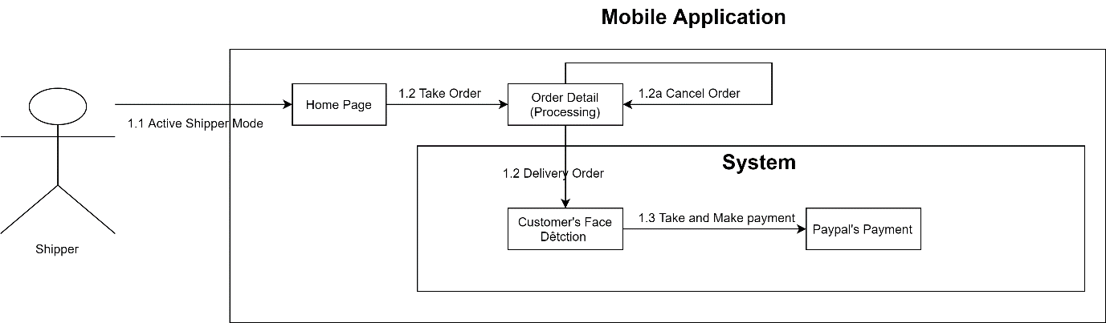Figure Admin Core Flow

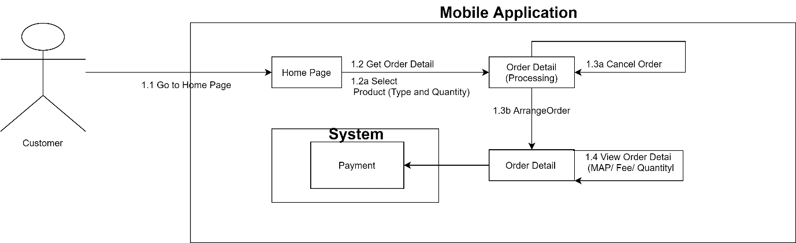Figure Shipper Core Flow

Figure Customer Core Flow

## **5.1 Admin Test Case**

### **5.1.1 Report Event**

|  |  |  |  |  |  |  |  |
| --- | --- | --- | --- | --- | --- | --- | --- |
| **ID** | **Test Case Description** | **Test Case Procedure** | **Expected output** | **Depend** | **Result** | **Date** | **Note** |
| 1 | Homepage | Click to Home Page | Show Homepage on browser | No | Show Homepage on browser | 14/04 |  |
| 2 | Report | Automatic | Show:   * Shipper * Customer * Store * Order * Ratio * Sold Product * Revenue * Paid Shipper | No | Show Automatic | 14/04 |  |

Table: Report Event

**5.1.2 Statistic Event**

|  |  |  |  |  |  |  |  |
| --- | --- | --- | --- | --- | --- | --- | --- |
| **ID** | **Test Case Description** | **Test Case Procedure** | **Expected output** | **Depend** | **Result** | **Date** | **Note** |
| 1 | Statistic | Select Chart | Show Statistic Chart | **Report Event** | Show Statistic Chart | 14/04/19 |  |

Table: Statistic Event